OUR SCHOOL NEWSLETTER
17TH OF SEPTEMBER

Welcome to our Newsletter. We are all settled back into the routine of school. We like having Ms. Slattery in the Senior Room but hope Ms. Wallace feels better soon.
A big welcome to Mr. Cannon who is our SEN teacher now.
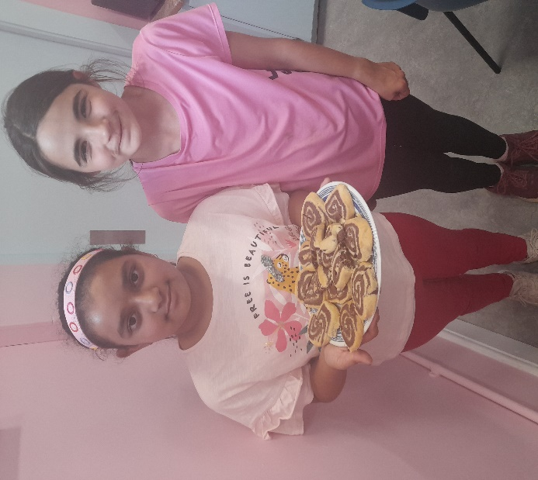
In the Junior Classroom, Séan donated lots of new books and toys. They really enjoyed making loom band bracelets. They went on a nature walk around the school, they found hazelnuts and a hazel tree.
Anna and Sadiya made shortbread spirals for Baking club. They were delicious!
They are also the new Referees for lunchtime games and they host all the games outside. The games are great fun.

A big welcome back to Kayleigh and Robert who plays sports and games with us on Fridays. We hope that in the future we have lots of fun with Kayleigh. .
The seniors are also doing ‘Spellings for Me’ where they use creative ways to spell and learn words; such as making them into pictures, mnemonics and creating silly sentences. We use the Ipads and the workbooks for ‘Spellings for Me’.

The Senior Room have been learning about World War 2. We learned that children were evacuated to the country side so that they would be safe from the bombs. Food was rationed. Also, the women had to take over the men’s jobs while they were at war. We re-created the posters they would make to persuade the women to do these jobs. We also wrote letters that children that were evacuated would have written to their parents from their new homes.
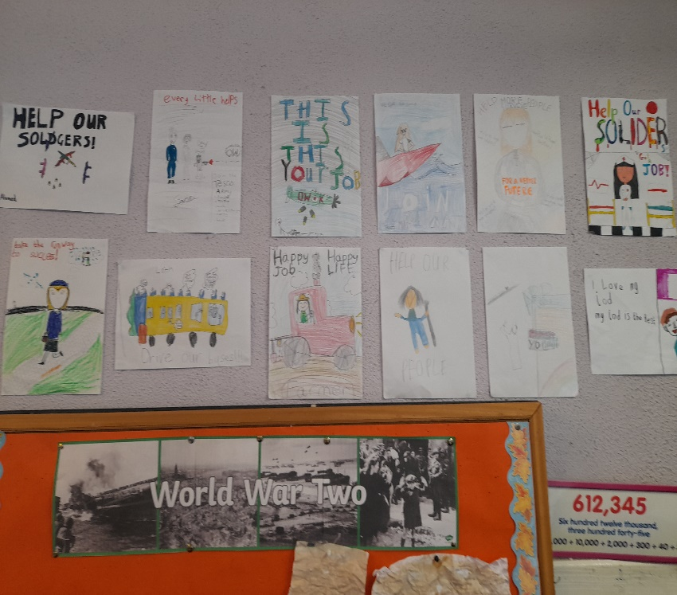
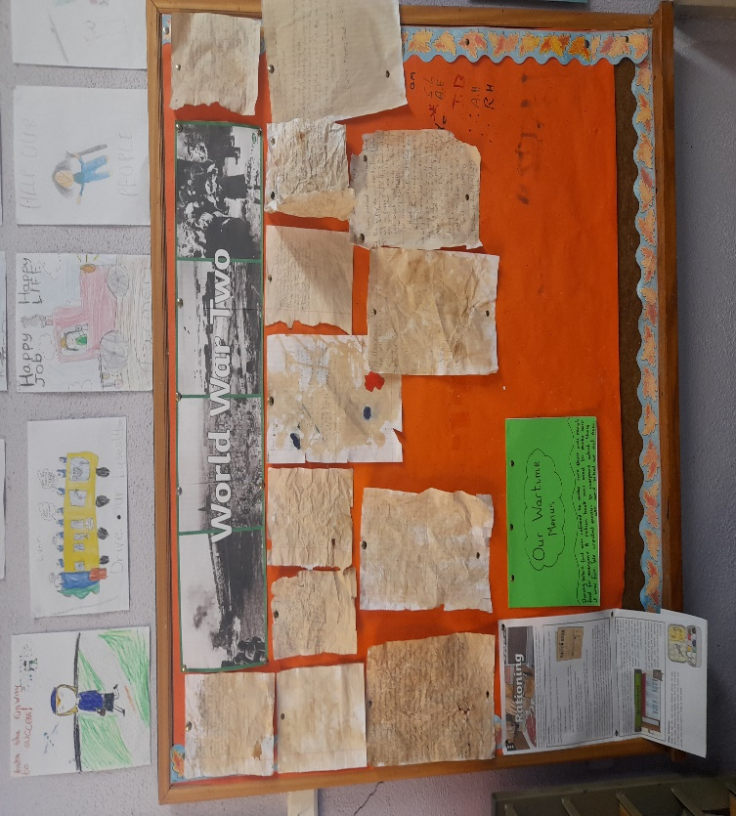

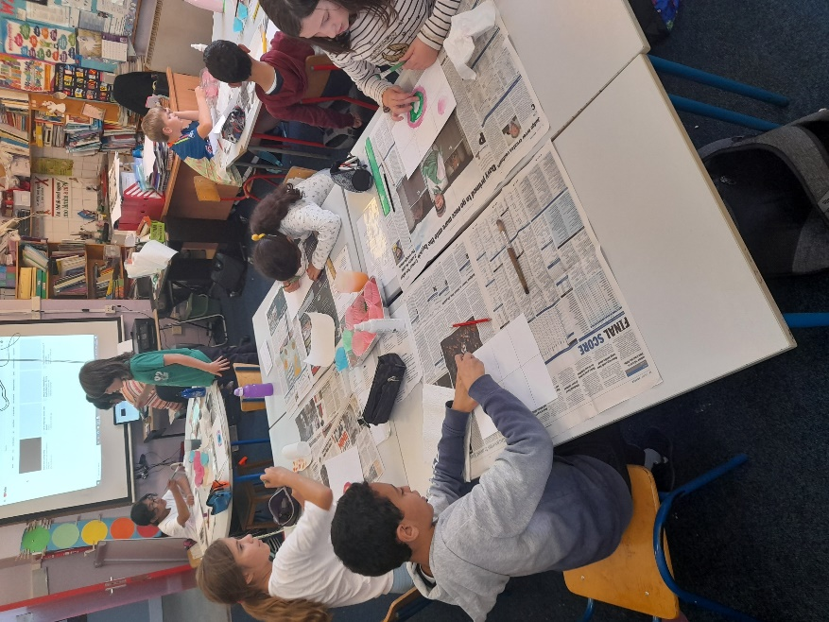
Every Tuesday, Ms. Slattery comes and we do Art in the Senior Room. This week we learned about the famous artist Kandinsky and painted very colorful abstract circles.
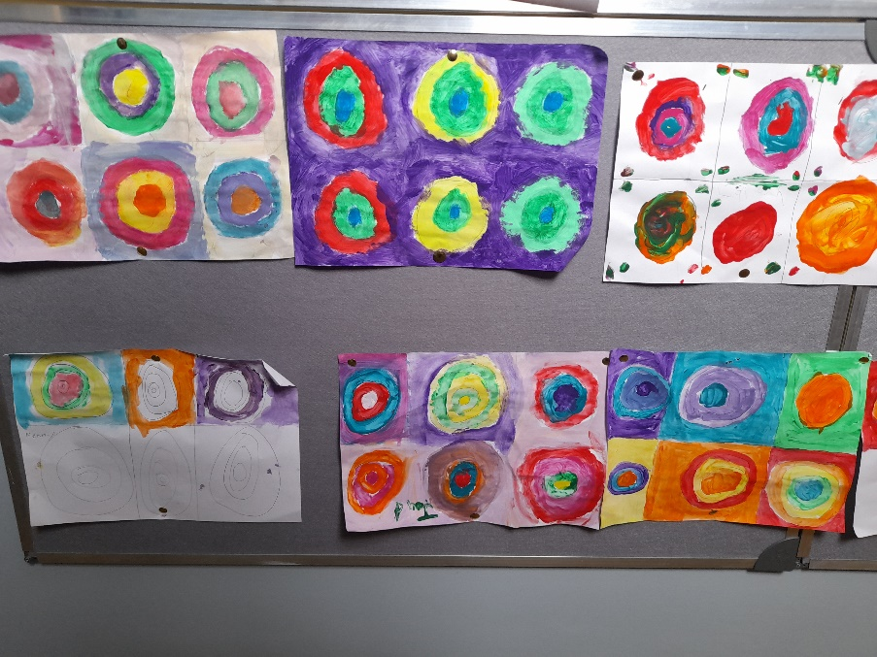

This week’s Newsletter was prepared by Sadiya and Anna.
Hope you all enjoyed reading our News

